Task 01:
Ubantu Installation Steps:
1: Go to Microsoft store and search ubantu and download the LTS version .
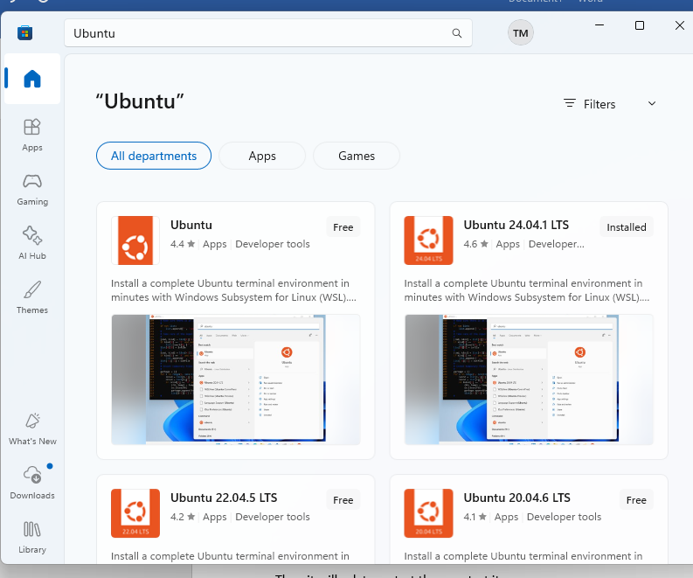

2: Open power shell and type wsl –install.
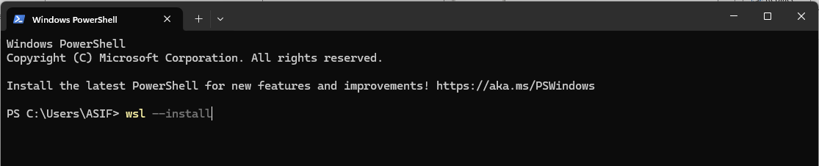

3.open menu and search Turn Windows features on or off and tick these two
- Windows Subsystem for Linux
- Virtual Machine Platform
Then it will ask to restart then re start it.
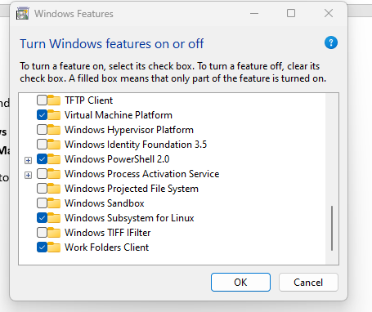

4: then Open ubanto and click on open then terminal will open then add user name and password and password will not show as you see but don’t worry write it.
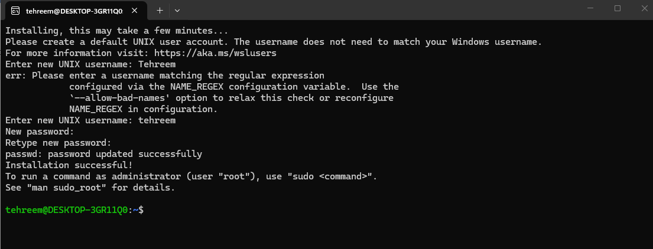
Look now you run commands :
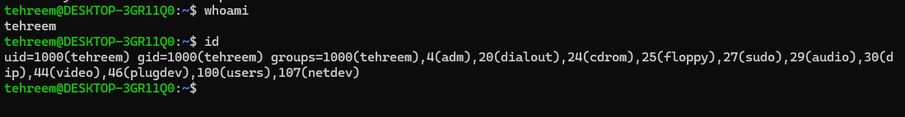

Task 02:
Signup with edu email your uni one .

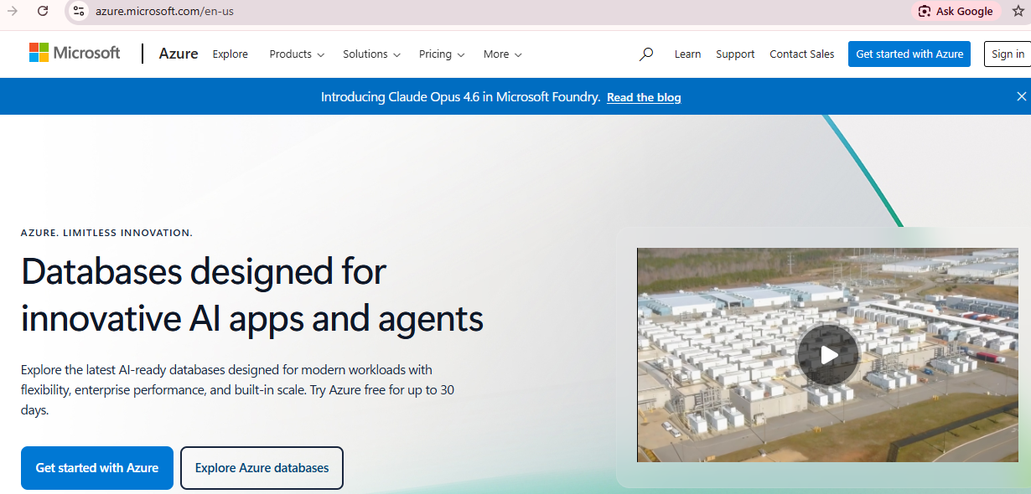

Select student option.
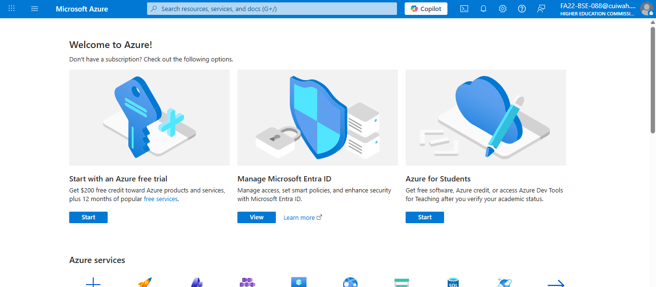

Then on signup and add details:
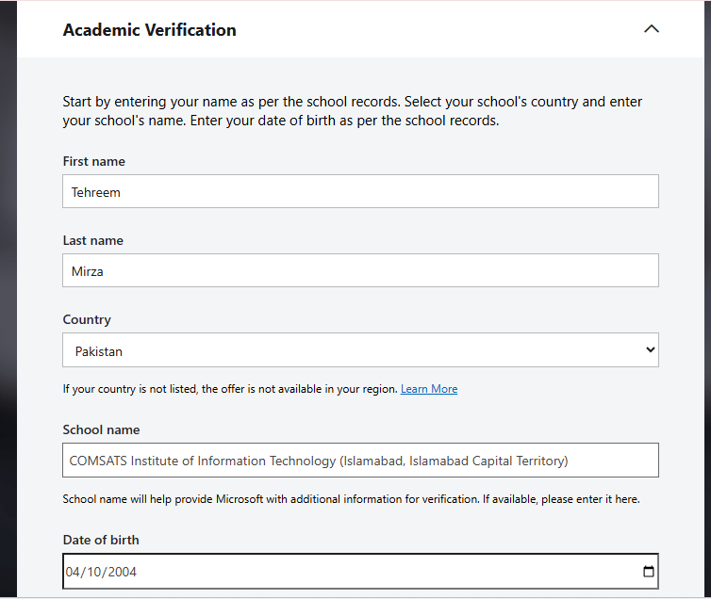

Account is been created:
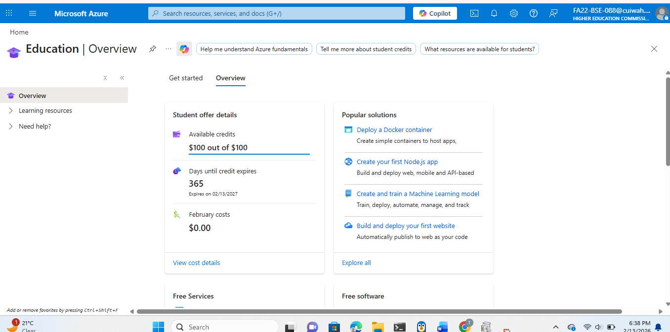

Task 04:
Already github desktop , gitbash install is done .. git hub online also account creation is done.
This is commands i run on it .
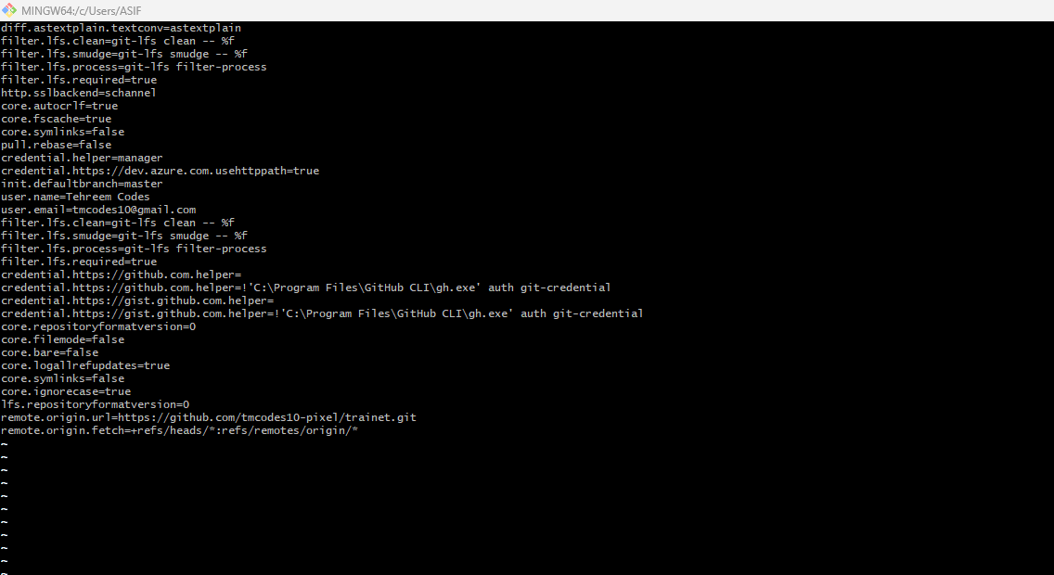

Now adding repository to
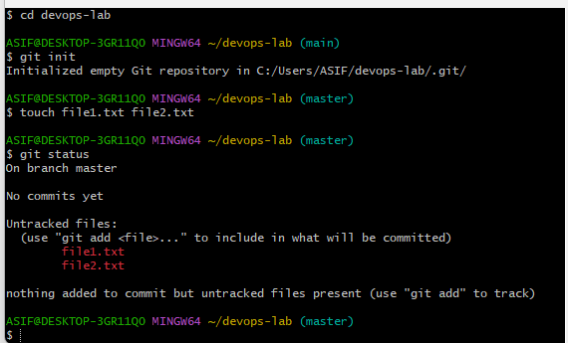

Create repository devops-lab and run these commands:
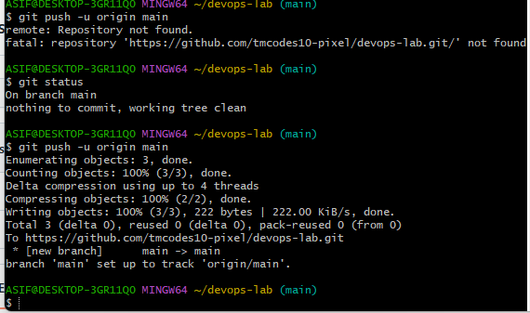

Look these files are now pushed on github.


